A database is an organised collection of data.

It is a collection of, Schemas, Tables, Queries, Reports, Views, and other objects. The data are typically organized to model aspects of reality, in a way that supports processes requiring information.

A **Database Management System (DBMS)** is an application that handles the database and interfaces; users and applications. Protects data integrity, adds new data, runs queries, user authorisation, …  
- Examples of DBMSs: Oracle, PostgreSQL, MS SQL server

The database itself can be abstracted into parts:

* Structure descriptions (schema)
* The data it contains (instance)
* Some implementation for choices and rules



# A text on a white background Description automatically generatedA white background with black text Description automatically generatedER Modelling

Disjoint: Every entity must be specialized but cannot be both



Binary, Ternary, etc.

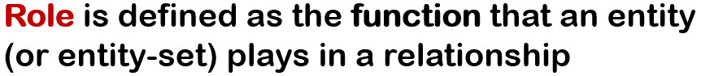d

Mapping Cardinality Constraints: Express the number of entities

to which another entity can be associated via a relationship set

Eliminate redundancy →

# A close up of text Description automatically generatedA close up of words Description automatically generatedThe Relational Model

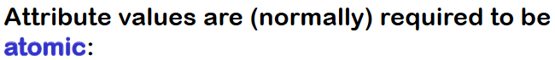



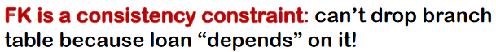

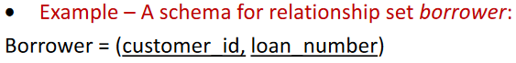

payment(loan_number, payment_number, payment_date, payment_amount)

Foreign Key loan_number referencing loan_number in loan table

# A close-up of a white background Description automatically generatedRelational Algebra

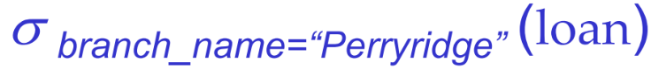

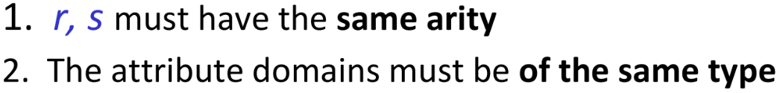

(Number of attributes)

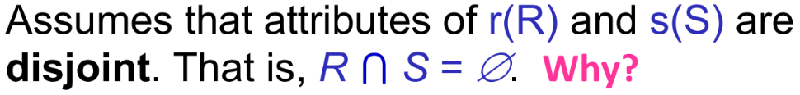

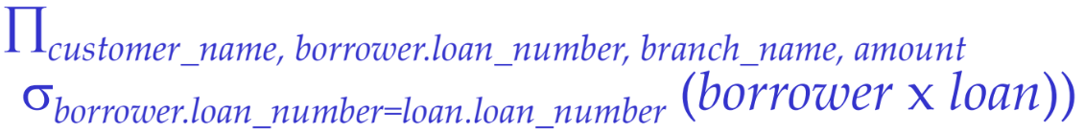

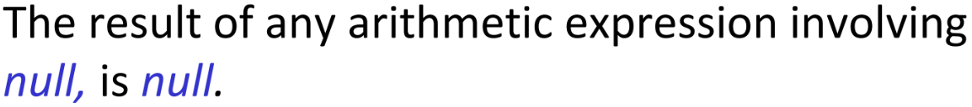

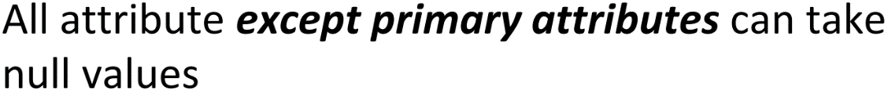

# A white background with black text Description automatically generatedA close-up of words Description automatically generatedSQL

Allows the specification of not only a set of relations but also information about each relation

* The schema for each relation
* The domain of values associated with each attribute
* Integrity constraints
* Security and authorization information for each relation
* The physical storage structure of each relation on disk

**create table** branch (branch_name varchar(15)**,** branch_city varchar(30), assets int, **primary key**(branch_name) )

**DROP TABLE branch**

**DROP TABLE branch CASCADE**

**alter table** r **add** A D

where *A* is the name of the attribute to be added to relation *r*  and *D* is the domain (type) of *A.*

**alter table** r **drop** A

**and, or, not union, intersect, except**

**where** amount **between** 90000 **and** 100000

between is inclusive

order by attribute = (asc) ascending order

order by attribute desc = descending order

**select distinct** branch_name **from** loan

**select all** branch_name **from** loan

all is the default behavior

**select** loan_number, branch_name, amount *100 **from** loan

**This does not change what is stored in the DB!**

Select * from loan = get all attributes from loan

**select \*** **from** borrower, loan = cartesian product

renaming using **as** clause

**AS** can appear *both* in the **select** and **from** clauses



**where***customer_street* **like '**%Main%' ;

**like '**Main\%' uses **escape ‘**\' to match ‘Main%’

Concatenation (using “**||**”)





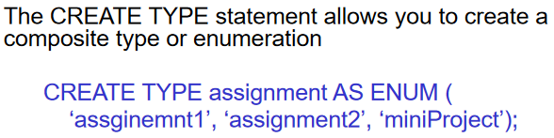

Referential integrity => foreign Keys

# Normalization theory

R could have been a single relation containing all attributes that are of interest (called universal relation)

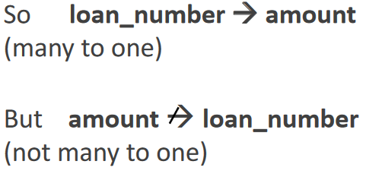

α implies the values of β deterministically

A → B does NOT hold

B → A does hold

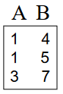

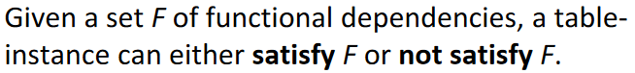

Each iteration of the repeat loop of the procedure, except the last iteration, adds at least one functional dependency to F+. Thus, the procedure is guaranteed to terminate.

(Note: the amount of FDs on a finite set of attributes is finite. )

To compute the closure of a set of FDs, F:

Let F+ := F;

repeat

for each functional dependency f in F+

- apply augmentation and reflexivity rules on f

for each pair of functional dependencies f1 and f2 in F+

- combine f1 and f2 using transitivity

until F+ does not change any further

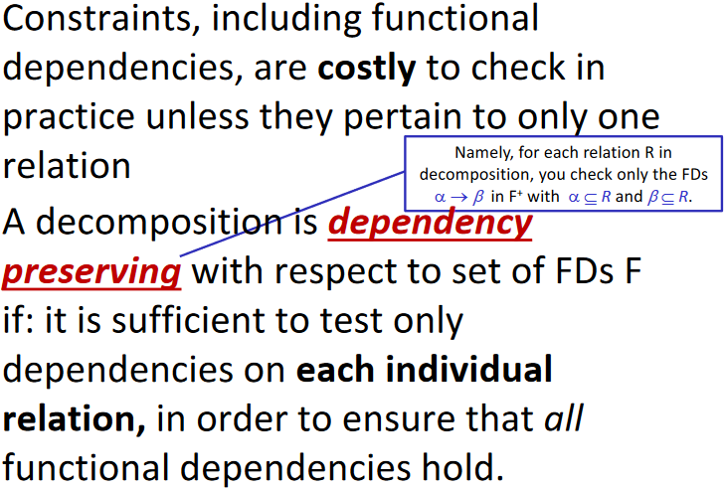

# A white background with black text Description automatically generatedTransactions

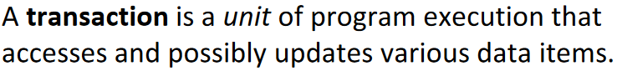

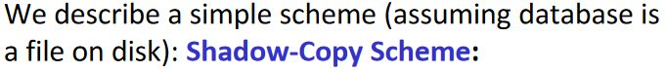



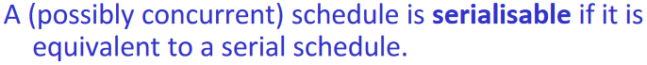



# Indexing

